
STUDENT CASE STUDY EXECUTION REPORT
Department | FED
Subject | DSA – 2
Academic Year | I-III Semester (2025 – 26)
Faculty Name | Ms. Mamatha
Student Name | Uppalapati Venkata Naga Varshitha
Roll Number | 2520030206
Branch | CSE
Course Outcome | CO 3 – Graph Algorithms for Logistics Networks

Case Study Title: Logistics Route Connectivity Analysis using Graph Algorithms in SmartLogix

Problem Statement:
SmartLogix manages transportation routes between warehouses and cities. Efficient connectivity analysis is required to verify transport network availability and detect routing loops.
In this case study, graph algorithms such as BFS and DFS are implemented to analyze logistics network connectivity.

Objectives:
- Represent logistics network using graphs
- Analyze connectivity using
- BFS Detect route traversal using DFS
- Improve transport network analysis
- Demonstrate graph-based logistics optimization

Algorithm Used:
Breadth First Search (BFS): Used to analyse connectivity between distribution centers.
Depth First Search (DFS): Used to traverse logistics routes and detect loops.

Code Implementation:
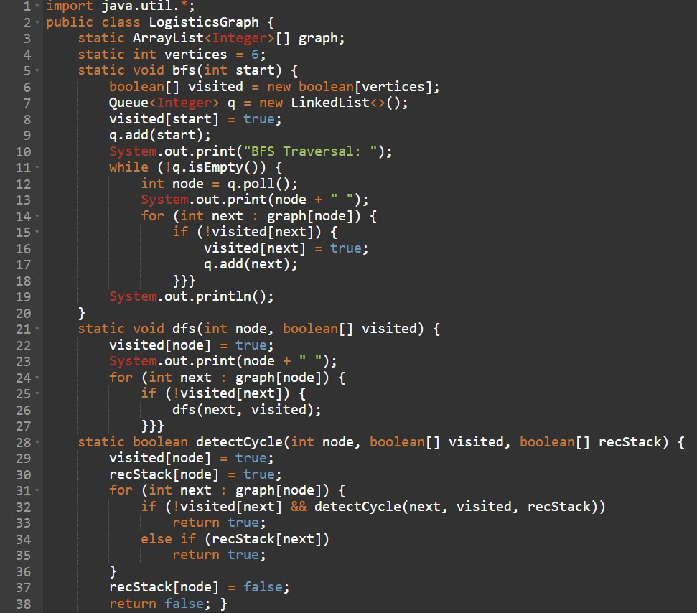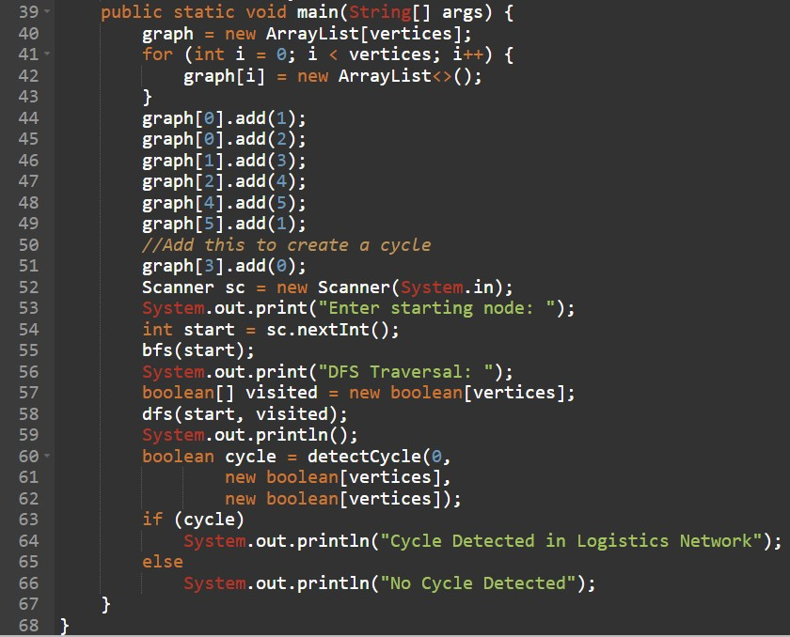

Sample Output:
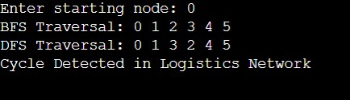

Result:
The graph algorithms successfully analyzed logistics network connectivity. BFS efficiently explored warehouse connectivity while DFS traversed logistics routes effectively.
Time Complexity:
- BFS: O (V+E)
- DFS: O (V+E)
- Cycle Detection: O (V+E)

Advantages:
- Efficient route analysis
- Improved transport network monitoring
- Easy connectivity checking
- Suitable for logistics optimization

Applications:
- Route planning systems
- Supply chain monitoring
- Delivery network analysis
- Warehouse connectivity analysis

Conclusion:
This case study demonstrated the importance of graph algorithms in logistics systems. BFS and DFS improved route analysis and connectivity management within SmartLogix.

Github Link: https://github.com/srinivasvarshi7-beep/DSA-2-Casestudy.git

Student Signature: | Faculty Signature:

